Set->

Second module.

\*1.2V

\*child interface of collection.

\* where duplicates cant repeat.

\*no insertion order preserved.

\*

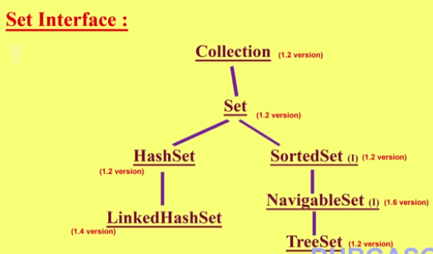

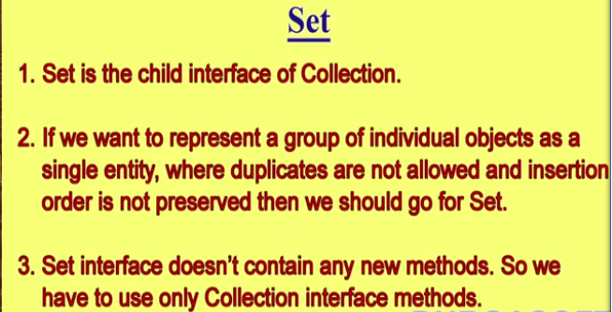

Hash Set->

\*Hash table data Structure.

\*not allowed duplicates.if we trying to add duplicates add method return “false “ in Boolean.

\*insertion order is not there.

Hash code for object.

\*heterogeneous object.

\*Null possible.

\*Serializable&Clonable

\*hash set best if our frequent opration in search.

Constructor->

1.HashSet h=new HashSet();

16->intitial capacity

0.75 fill ratio /load factor->after filling 75%filled new space created.

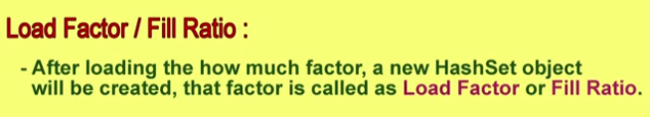

2.HashSet h=new HashSet(int INitialicapacity);

Fill factor-0.75;

3.HashSet h=new HashSet(int initiacap,Float loadfactor);

4.HashSet h=new HashSet( collection c);

For internal conversion b/w collection objects.

